Experiment No. - 1

**Student Name:** ANIKET KUMAR **UID:** 20BCS5306

**Branch:** CSE **Section/Group:** 20BCS_WM-703 / B

**Semester:** 5th **Date of Performance:** 16th Aug, 2022

**Subject Name:** Machine Learning Lab **Subject Code:** 20CSP-317

**1.1 Aim/Overview of the practical:** Exploratory Data Analysis on any data set.

* 1. **Task to be done:** Perform EDA on any given data set.
  2. **Apparatus/Simulator used:**
* Windows 7 or above
* Browser (Google Chrome, Mozilla Firefox, Microsoft Edge, etc.)
* Google Colab Notebook

# 1.4. Code:

# 

# import numpy as np

# import pandas as pd

# import matplotlib as mp

# pokemon_data = pd.read_csv("Pokemon.csv")

# 

# pokemon_data

# 

1. pokemon_data.head(10)

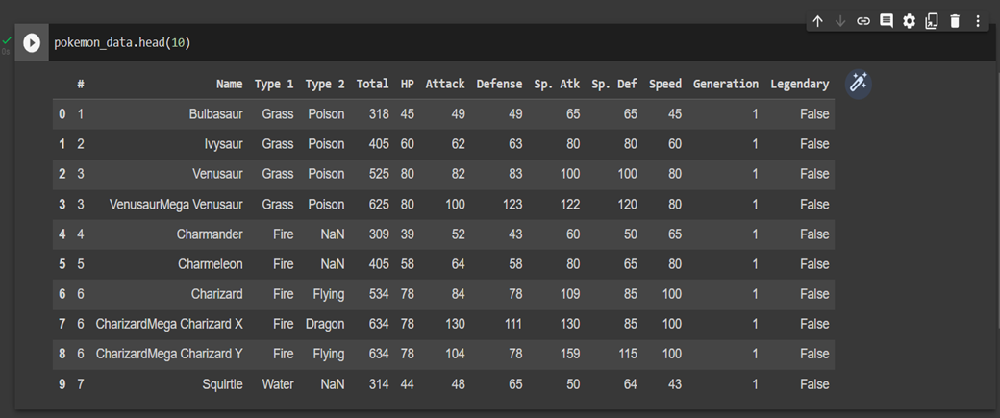

1. pokemon_data.info()

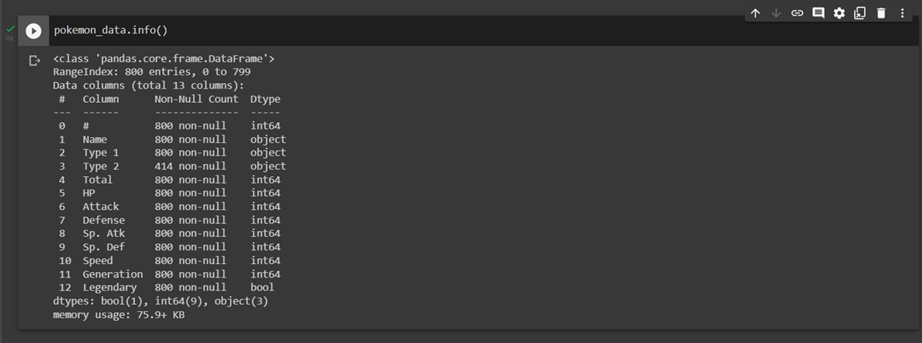

1. pokemon_data.loc[2]

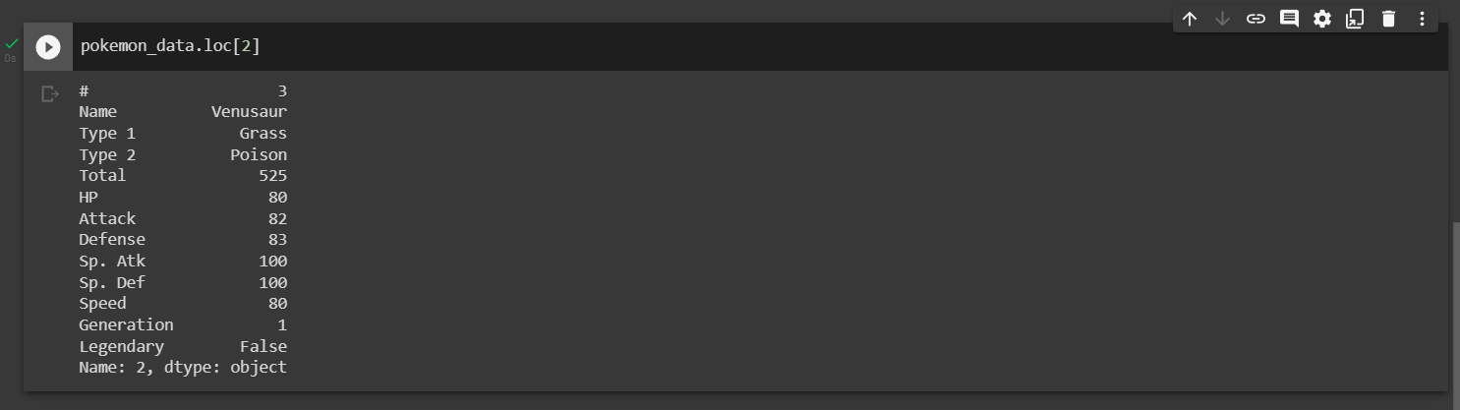

1. pokemon_data.describe()

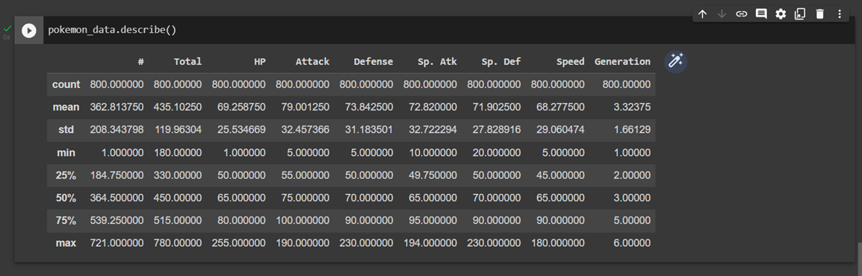

**Evaluation Grid (To be created as per the SOP and Assessment guidelines by the faculty):**

|  |  |  |  |
| --- | --- | --- | --- |
| Sr. No. | Parameters | Marks Obtained | Maximum Marks |
| 1. |  |  |  |
| 2. |  |  |  |
| 3. |  |  |  |
|  |  |  |  |